Project Development Phase
Model Performance Test
Date | 08 October 2026
Team ID | 9100Orbit
Project Name | Implement Client Script & UI Policy (Incident)
Maximum Marks
Model Performance Testing:
Project team shall fill the following information in model performance testing template.
S.No. | Parameter | Values | Screenshot
1. | Model Summary | ServiceNow Incident form automation using UI Policy and Client Scripts for data validation.  Note : If Impact is High, Assignment group becomes mandatory, Urgency is set to High and made read-only, and the Incident can be saved only when Assigned to is filled. Otherwise it will show an error. | 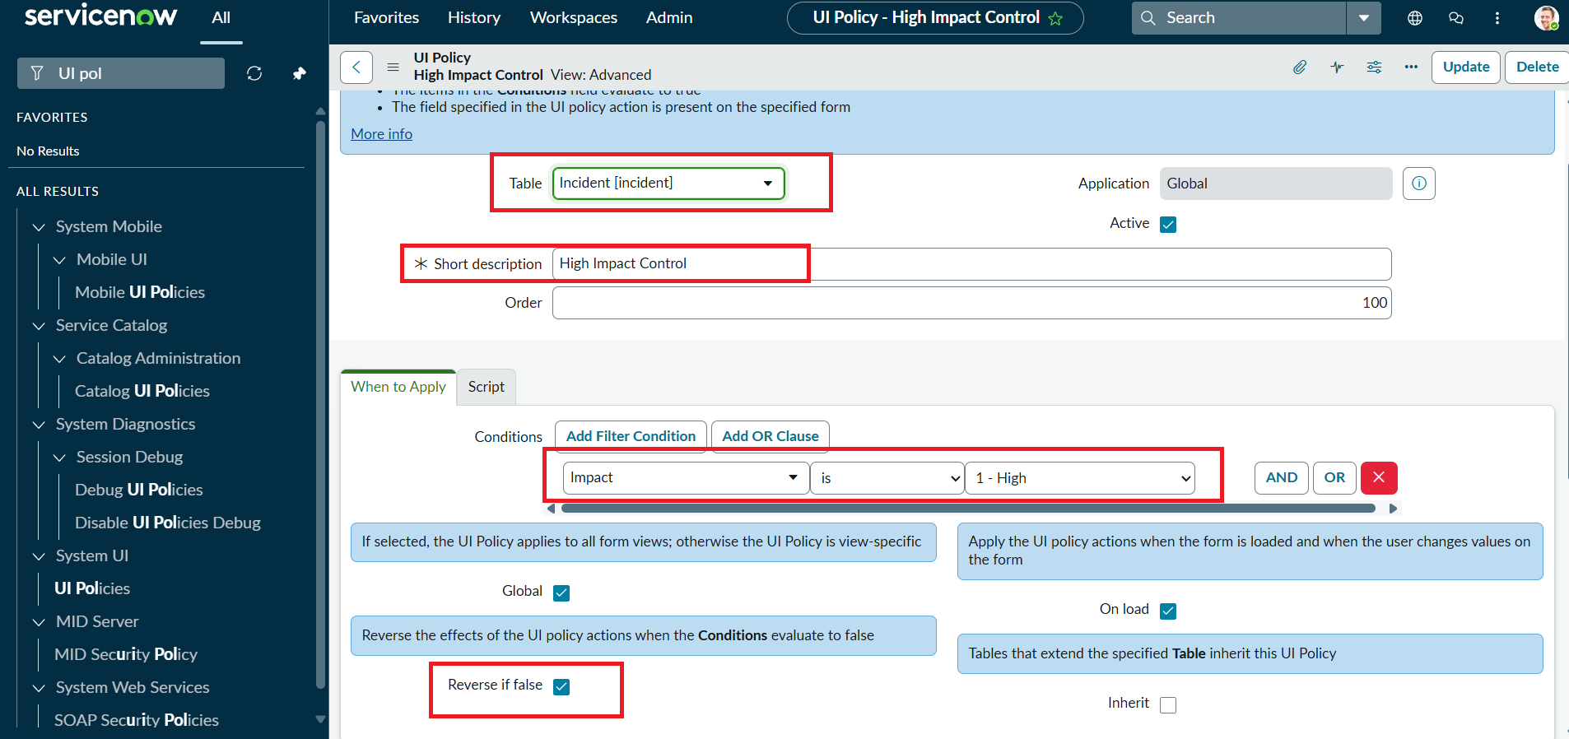
2. | Accuracy | Test Pass Rate (Accuracy):  Training Accuracy - Not applicable (no ML model)  Validation Accuracy - 100% (7 of 7 test scenarios passed)  Valid input: Incident saved successfully.  Invalid input: save blocked with error. | 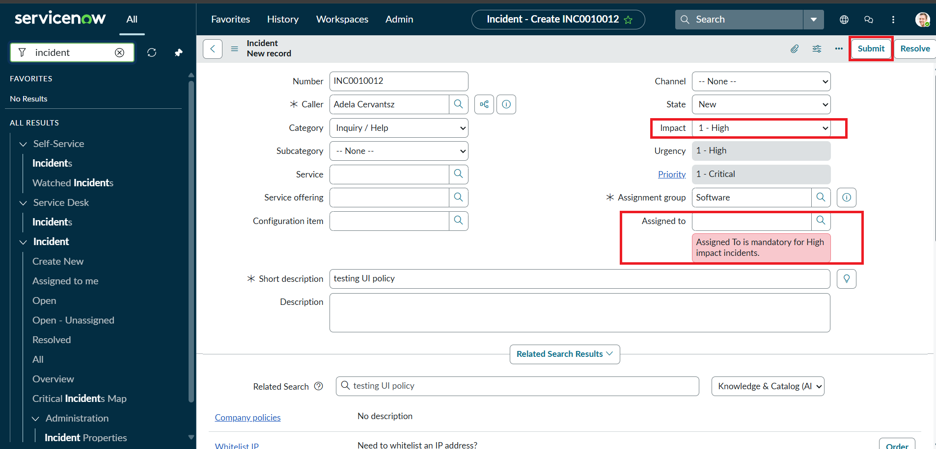  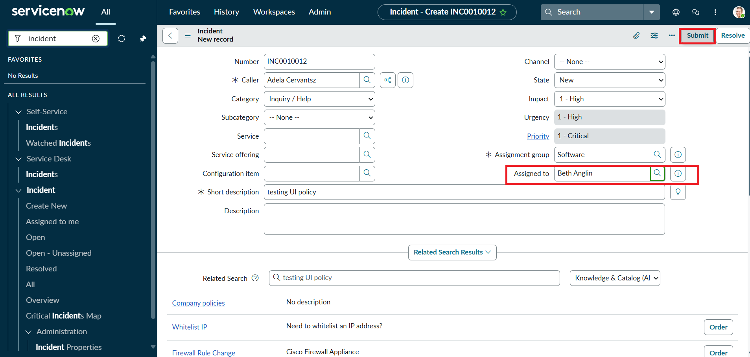
3. | Confidence Score (Only Yolo Projects) | Class Detected - Not applicable (not a YOLO project).  Validation Detection - If Impact is High and Assigned to is empty, the error "Assigned To is mandatory for High impact incidents." is shown. Direct State edit from list shows the alert "State cannot be changed from the list. Please open the Incident." | 